**QUERY:**

create table flights(

flno int,

ffrom varchar(20), tto varchar(20), distance int,

depart timestamp, arrives timestamp, price int,

primary key(flno));

create table aircrafts(

aid int,

aname varchar(20), cruisingrange int,

primary key(aid));

**LAB 5**

**AIRLINE FLIGHT DATABASES**

create table employess(

eid int,

ename varchar(20), salary int,

primary key(eid));

create table certified(

eid int, aid int,

foreign key(eid) references employess(eid), foreign key(aid) references aircrafts(aid));

insert into aircrafts values('&aid','&aname','&cruisingrange');

commit;

insert into employess values('&eid','&ename','&salary');

commit;

insert into certified values('&eid','&aid');

commit;

alter session set nls_timestamp_format='rr/mm/dd hh24:mi:ssxff';

alter session set nls_date_language ='english';

insert into flights values('&flno','&ffrom','&tto','&distance','&depart','&arrives','&price'); commit;

select * from flights; select * from aircrafts; select * from employess; select * from certified;

select distinct aname from aircrafts where aid in(select c.aid from certified c, employess e where c.eid=e.eid and

not exists( select * from employess e1 where e1.eid=e.eid and e1.salary<80000));

select c.eid ,max(a.cruisingrange) from certified c, aircrafts a where

c.aid=a.aid group by c.eid having count(*)>3;

select ename from employess

where salary<(select min(f.price) from

flights f where f.ffrom='bangalore' and f.tto='frankfurt');

select a.aname, e.salary from

aircrafts a,employess e, certified c where

c.aid=a.aid and c.eid=e.eid and a.cruisingrange>1000 group by a.aid,a.aname;

select temp.name, temp.avgsalary

from ( select a.aid, a.aname as name, avg (e.salary) as avgsalary from aircrafts a, certified c, employess e

where a.aid = c.aid and c.eid = e.eid and a.cruisingrange > 1000 group by a.aid, a.aname ) temp;

select distinct e.ename from employess e, certified c, aircrafts a where e.eid=c.eid and c.aid=a.aid and a.aname like 'boeing%';

select aid from aircrafts a

where a.cruisingrange>(select min(f.distance) from flights f where f.ffrom='bangalore' and f.tto='frankfurt');

select f.depart from flights f

where f.flno in ( ( select f0.flno from flights f0

where f0.ffrom = 'bangalore' and f0.tto = 'delhi' and extract(hour from f0.arrives) < 18 )

union

( select f0.flno

from flights f0, flights f1

where f0.ffrom = 'bangalore' and f0.tto <> 'delhi' and f0.tto = f1.ffrom and f1.tto = 'delhi'

and f1.depart > f0.arrives

and extract(hour from f1.arrives) < 18)

union

( select f0.flno

from flights f0, flights f1, flights f2 where f0.ffrom = 'bangalore'

and f0.tto = f1.ffrom and f1.tto = f2.ffrom and f2.tto = 'delhi' and f0.tto <> 'delhi' and f1.tto <> 'delhi'

and f1.depart > f0.arrives and f2.depart > f1.arrives

and extract(hour from f2.arrives) < 18));

select e.ename, e.salary from employess e

where e.eid not in ( select distinct c.eid from certified c )

and e.salary >( select avg (e1.salary)

from employess e1 where e1.eid in

( select distinct c1.eid from certified c1 ) );

**OUTPUTS:**

Flight table:

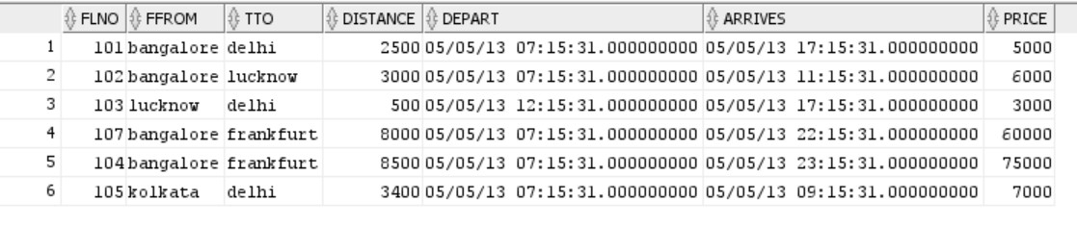

Aircrafts table: employees table:

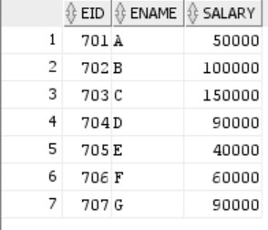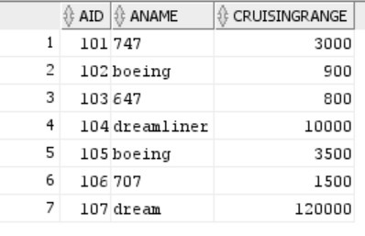

Certified table:

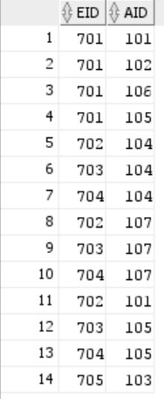

Query 1: Query 2: Query 3:

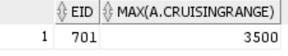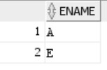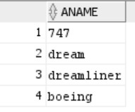

Query 4:

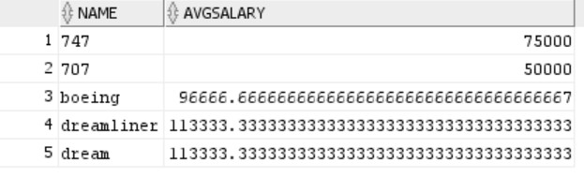

Query 5: Query 6: Query 7:

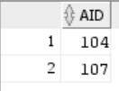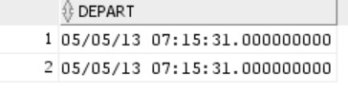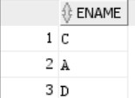

Query 8:

